**Streamlining Ticket Assignment for Efficient Support Operations**

**Team Id: NM2025TMID20153**

**Team Members: 04**

**Team Leader: ROHITH KUMAR V**

**Team Member: RAHUL V**

**Team Member: AVINASH D**

**Team Member: SAMEER R**

**Problem statement:**

In most organizations, support teams manage a large number of queries using ticketing systems. However, ticket assignment is usually handled manually or with simple rules. This process often leads to delays in response time, uneven distribution of work among support agents, and incorrect assignment of tickets. As a result, productivity decreases and customer satisfaction is affected. To overcome these challenges, there is a need for a streamlined and automated ticket assignment system that can intelligently analyze ticket information (such as category, priority, and keywords) and assign it to the most suitable agent quickly and efficiently.

**Objective:**

1. Automate Ticket Assignment – Reduce manual effort by assigning tickets automatically to the right support agent.
2. Ensure Fair Workload Distribution – Balance tickets among agents to avoid overloading.
3. Improve Response & Resolution Time – Speed up ticket handling for faster customer support.
4. Enhance Accuracy – Assign tickets based on category, priority, and keywords to minimize errors.
5. Boost Customer Satisfaction – Deliver quick and efficient solutions to customer queries.
6. Provide Monitoring & Insights – Track ticket flow and agent performance using dashboards/reports.

**Skills:** Users, Groups. Roles, Tables, Access Control List, Flow Designer

**TASK INITIATION**

**Milestone 1 : Users**

**Activity 1:** **Create Users**

1. Open service now.
2. Click on All  >> search for users
3. Select Users under system security
4. Click on new
5. Fill the following details to create a new user  
   A screenshot of a computer

   AI-generated content may be incorrect.
6. Click on submit

**Create one more user:**

1. Create another user with the following details
2. Click on submit

**Milestone 2 : Groups**

**Activity 1:** **Create Groups**

1. Open service now.
2. Click on All >> search for groups
3. Select groups under system security
4. Click on new
5. Fill the following details to create a new group

1. Click on submit

**Create one more group:**

1. Create another group with the following details  
   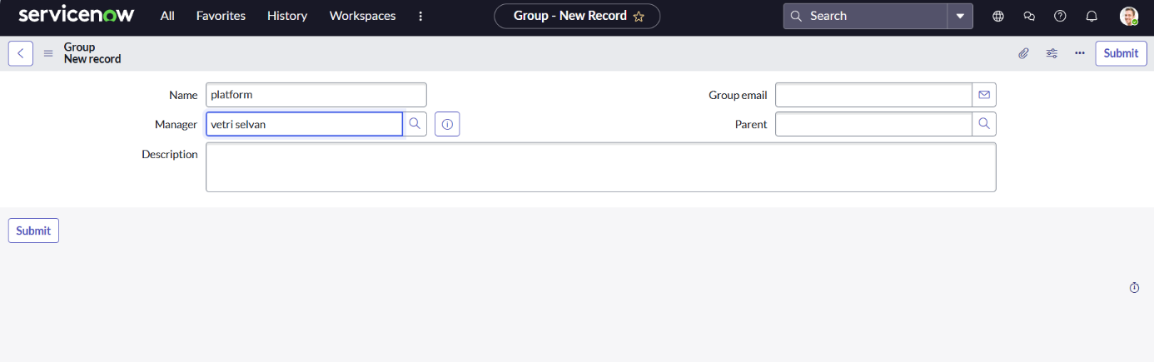
2. Click on submit

**Milestone 3 : Roles**

**Activity 1:** **Create role.**

1. Open service now.
2. Click on All  >> search for roles
3. Select roles under system security
4. Click on new
5. Fill the following details to create a new role

1. Click on submit

**Create one more role:**

Create another role with the following details

Click on submit

**Milestone 4 : Table Activity 1: Create Table**

* 1. Open service now.
  2. Click on All  >> search for tables
  3. Select tables under system definition
  4. Click on new
  5. Fill the following details to create a new table  
     Label : Operations related  
     Check the boxes Create module & Create mobile module
  6. Under new menu name : Operations related
  7. Under table columns give the columns  
     A screenshot of a computer

     AI-generated content may be incorrect.
  8. Click on submit

**Create choices for the issue filed by using form design  
Choices are**

* 1. unable to login to platform
  2. 404 error
  3. regarding certificates
  4. regarding user expired

**Milestone 5 : Assign role users to groups**

**Activity 1: Assign roles & users to certificate group**

1. Open service now.
2. Click on All  >> search for tables
3. Select tables under system definition
4. Select the certificates group
5. Under group members
6. Click on edit
7. Select Lingeshwaren and save
8. Click on roles
9. Select Certification_role and save

**Activity 1: Assign roles & users to platform group**

1. Open service now.
2. Click on All  >> search for tables
3. Select tables under system definition
4. Select the platform group
5. Under group members
6. Click on edit
7. Select Vetri Selvan and save
8. Click on roles
9. Select Platform_role and save

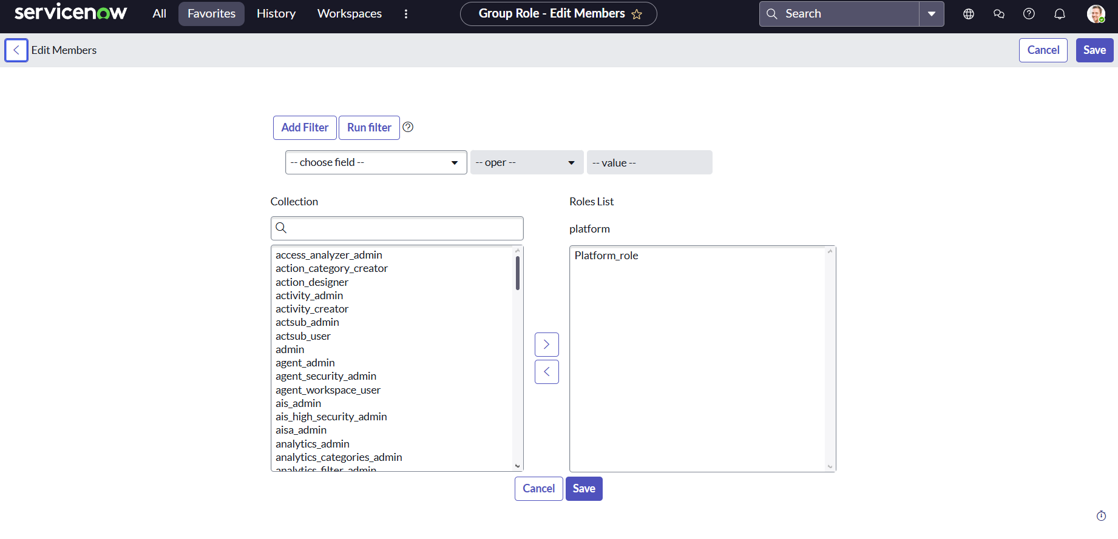

**Milestone 6 : Assign roles to users**

1. Open service now.
2. Click on All  >> search for tables
3. Select operations related table
4. Click on the Application Access
5. Click on u_operations_related read operation
6. Click on the profile on top right side
7. Click on elevate role
8. Click on security admin and click on update
9. Under Requires role
10. Double click on insert a new row
11. Give platform role
12. And add certificate role
13. Click on update  
    A screenshot of a computer

    AI-generated content may be incorrect.

14.Click on u_operations_related write operation

15.Under Requires role

16.Double click on insert a new row

17.Give platform role

18.And add certificate role

**Milestone 7 : Create ACL**

1. Open service now.
2. Click on All  >> search for ACL
3. Select Access Control(ACL) under system security
4. Click on new
5. Fill the following details to create a new ACL

1. Scroll down under requires role
2. Double click on insert a new row
3. Give admin role
4. Click on submit
5. Similarly create 4 acl for the following fields

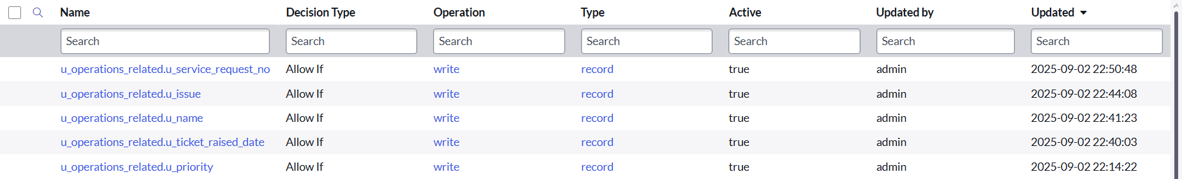

**Milestone 8 : Flow**

**Activity 1: Create a Flow to Assign operations ticket to group**

1. Open service now.
2. Click on All  >> search for Flow Designer
3. Click on Flow Designer under Process Automation.
4. After opening Flow Designer Click on new and select Flow.
5. Under Flow properties Give Flow Name as “ Regarding Certificate”.
6. Application should be Global.
7. Select Run user as “ System user ” from that choice.
8. Click on Submit.

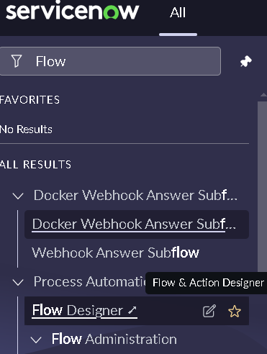

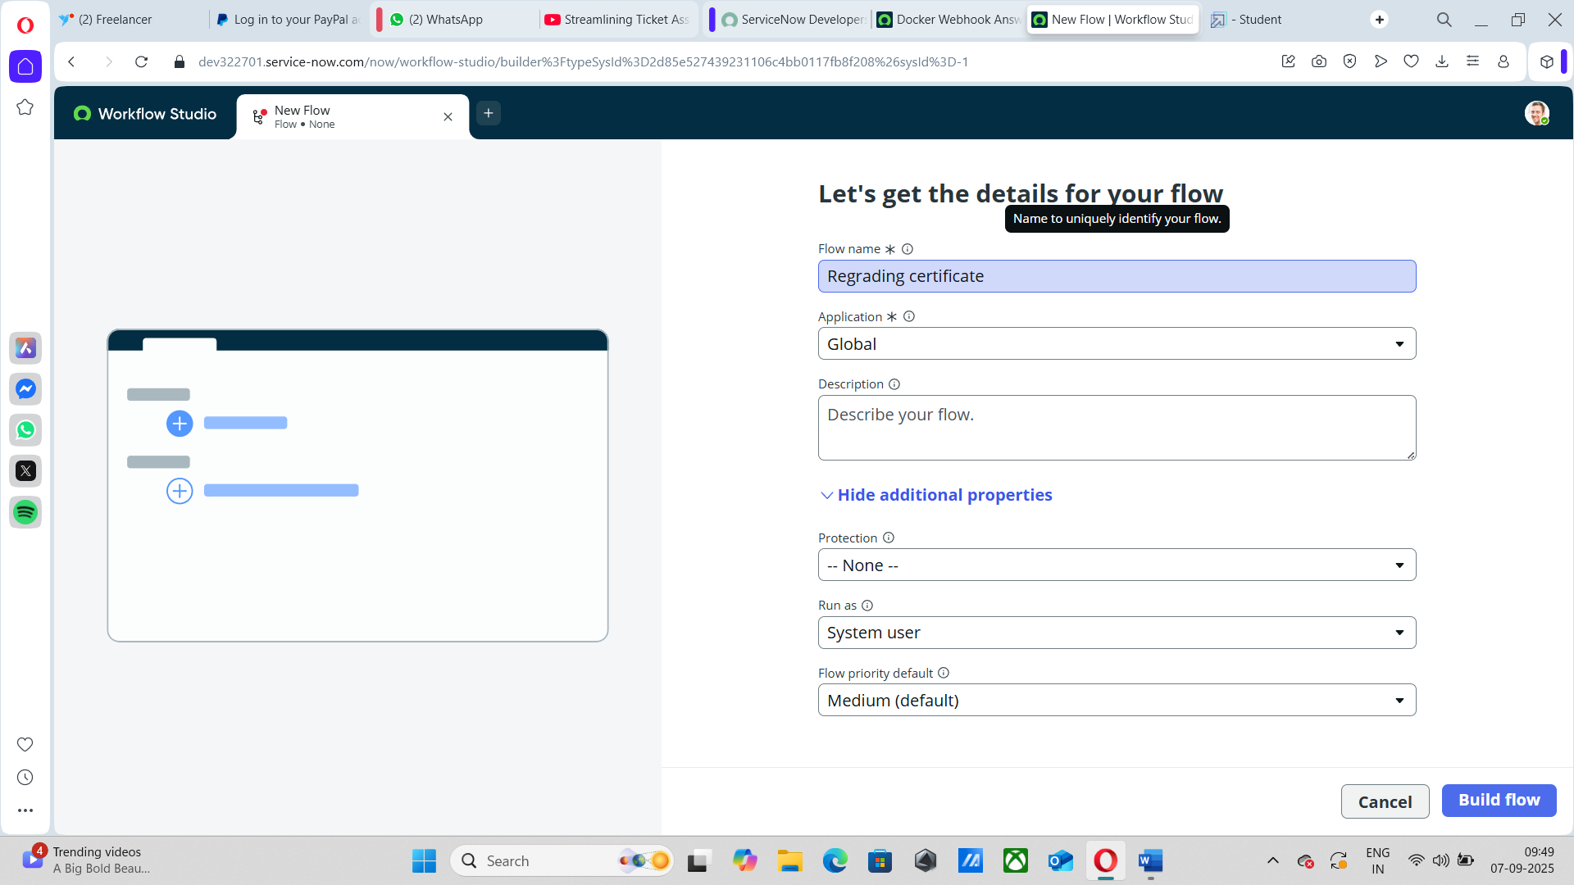

1. Click on Add a trigger
2. Select the trigger in that Search for “create or update a record”  and select that.
3. Give the table name as “ Operations related ”.
4. Give the Condition as  
   Field : issue
5. Operator : is
6. Value : Regrading Certificates
7. After that click on Done.

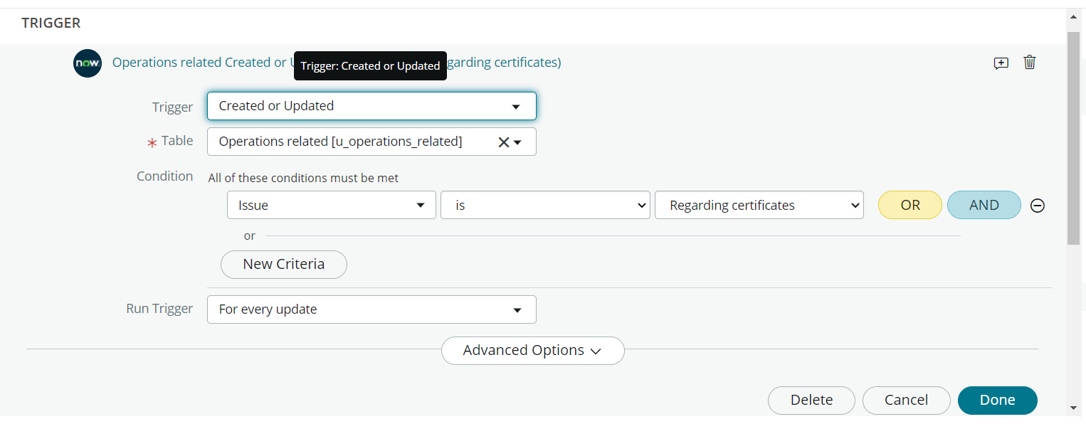

1. Now under Actions.
2. Click on Add an action.
3. Select action in that search for “ Update Record ”.
4. In Record field drag the fields from the data navigation from left side
5. Table will be auto assigned after that
6. Give the field as “ Assigned to group ”
7. Give value as “ Certificates ”
8. Click on Done.
9. Click on Save to save the Flow.
10. Click on Activate

**Activity 1:** **Create a Flow to Assign operations ticket to Platform group**

1. Open service now.
2. Click on All  >> search for Flow Designer
3. Click on Flow Designer under Process Automation.
4. After opening Flow Designer Click on new and select Flow.
5. Under Flow properties Give Flow Name as “ Regarding Platform ”.
6. Application should be Global.
7. Select Run user as “ System user ” from that choice.
8. Click on Submit.

1. Click on Add a trigger
2. Select the trigger in that Search for “create or update a record”  and select that.
3. Give the table name as “ Operations related ”.
4. Give the Condition as  
   Field : issue

Operator : is

Value : Unable to login to platform

1. Click on New Criteria

Field : issue

Operator : is

Value : 404 Error

1. Click on New Criteria

Field : issue

Operator : is

Value : Regrading User expired

1. After that click on Done.
2. Now under Actions.
3. Click on Add an action.
4. Select action in that search for “ Update Record ”.
5. In Record field drag the fields from the data navigation from left side
6. Table will be auto assigned after that
7. Give the field as “ Assigned to group ”.
8. Give value as “ Platform ”.
9. Click on Done.
10. Click on Save to save the Flow.
11. Click on Activate.

**Conclusion :**

The implementation of the automated ticket routing system at ABC Corporation has been a significant success. By leveraging the capabilities of ServiceNow, we have streamlined the process of assigning support tickets to the appropriate teams, addressing the challenges of manual routing, and ensuring timely resolution of issues.